Ricoh Theta X 360-degree camera setup

This document outlines how to set up the 360-degree camera to view the livestream on an Ubuntu system. It has been tested and verified on Ubuntu 20.04 which is the operating system running on the ITX computer.  
  
Theoretically it would be better to have the camera livestream to the PX2. However, this has not been verified to work as of now since the PX2 operates on Ubuntu 16.04.  
  
<https://community.theta360.guide/t/live-stream-ricoh-theta-x-on-ubuntu-22-04/7992>

**Prerequisites**

* Ricoh Theta X 360-degree camera.
* Computer that runs Ubuntu 20.04 or newer version

Also, install the following packages:

* make
* libusb-1.0
* libjpeg-dev
* libgstreamer1.0-dev
* libgstreamer-plugins-base1.0-dev
* libgstreamer-plugins-bad1.0-dev
* gstreamer1.0-plugins-base
* gstreamer1.0-plugins-good
* gstreamer1.0-plugins-bad
* gstreamer1.0-plugins-ugly
* gstreamer1.0-libav
* gstreamer1.0-tools
* gstreamer1.0-x
* gstreamer1.0-alsa
* gstreamer1.0-gl
* gstreamer1.0-gtk3
* gstreamer1.0-qt5
* gstreamer1.0-pulseaudio

**Steps**

|  |
| --- |
| $ git clone https://github.com/ricohapi/libuvc-theta.git $ git clone https://github.com/ricohapi/libuvc-theta-sample.git  $ cd libuvc-theta $ mkdir build $ cd build $ cmake .. $ sudo make install $ cd .. $ cd libuvc-theta-sample $ cd gst |

Now we need to change things in the file ***thetauvc.c***to operate the camera. The original guide for these steps can be found [here](https://community.theta360.guide/t/live-stream-ricoh-theta-x-on-ubuntu-22-04/7992).

Add definition for THETAX camera.

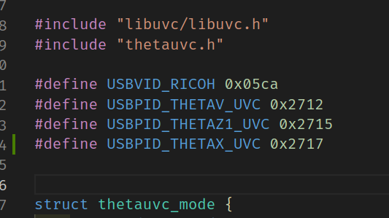

The hex-number is the number you receive when running the camera in live-mode and check USB connections with **lsusb** in Linux.

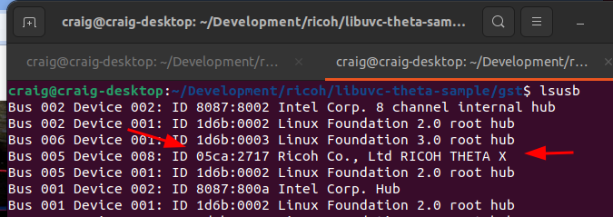

After you add the definition, add an or check in the if statement that checks for the idProduct and have it accept the THETAX in addition to THETAV and THETAZ1.

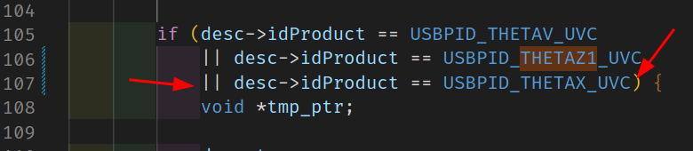

Finally build and run the program

|  |
| --- |
| $ make $ /gst_viewer |

Enjoy the pretty viewport!